**LEGENDS**

**Definition:** Legend is an area on the graph that describes each element that makes up the.

A legend is a predefined function **legend()** that creates an area on the graph which describes all the elements of a graph.

**Example program:**

**Step 1- Importing Libraries.**

import matplotlib.pyplot as plt import numpy as np

**Step 2- Creating Arrays.**

x=np.array([2,5,7,9,10,11,15,18,21,24,27,33,38,40,55,64]) y=np.array([5,1,9,5,10,13,19,15,21,24,28,35,41,45,50,71])

**Step 3- Plotting Graph without legend**.

plt.plot(x, y, label = "line_sample", color='r')

plt.xlabel('xaxis')

plt.ylabel('yaxis')

**Step 4- Plotting Graph with Legend.**

plt.plot(x, y, label = "line_sample", color='r') plt.xlabel('xaxis') plt.ylabel('yaxis') plt.legend()

**Output:**

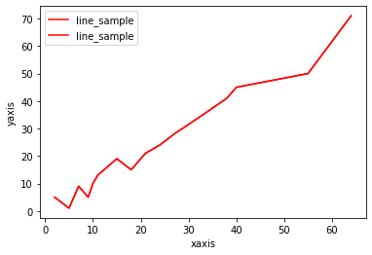

**There are four cases in Legends :**

1. Legends in left-bottom of the graph

2. Legends in centre of the graph

3. Legends in Right-bottom of the graph

4. Legends for size of points

**Legends in left-bottom of the graph**

import numpy as np

import matplotlib.pyplot as plt

x = np.linspace(0, 10, 1000)

fig, ax = plt.subplots()

ax.plot(x, np.sin(x), '--b', label ='Sine')

ax.plot(x, np.cos(x), c ='r', label ='Cosine')

ax.axis('equal')

leg = ax.legend(loc ="lower left");

**Output:**

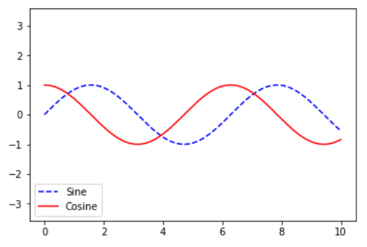

**Legends in centre of the graph**

import numpy as np

import matplotlib.pyplot as plt

x = [0, 1, 2, 3, 4, 5, 6, 7, 8]

y1 = [0, 3, 6, 9, 12, 15, 18, 21, 24]

y2 = [0, 1, 2, 3, 4, 5, 6, 7, 8]

plt.plot(y1, label ="y = x")

plt.plot(y2, label ="y = 3x")

plt.legend(bbox_to_anchor =(0.75, 1.15), ncol = 2)

plt.show()

**Output:**

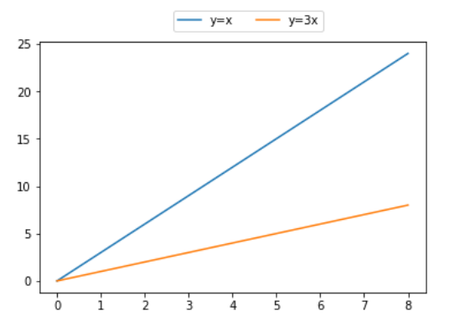

**Legends in Right-bottom of the graph**

import numpy as np

import matplotlib.pyplot as plt

y1 = [2, 3, 4.5]

y2 = [1, 1.5, 5]

plt.plot(y1)

plt.plot(y2)

plt.legend(["blue", "green"], loc ="lower right")

plt.show()

**Output:**

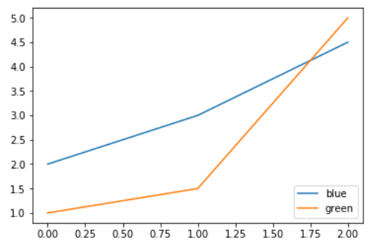

**Legends for size of points**

import matplotlib.pyplot as plt

import numpy as np

def rand_data():

return np.random.uniform(low=0., high=1., size=(100,))

x1, y1 = [rand_data() for i in range(2)]

x2, y2 = [rand_data() for i in range(2)]

plt.figure()

plt.scatter(x1, y1, marker='o', label='first', s=20., c='b')

plt.scatter(x2, y2, marker='o', label='second', s=35., c='r')

plt.legend(loc="lower left", markerscale=2., scatterpoints=1, fontsize=10)

plt.show()

**Output:**

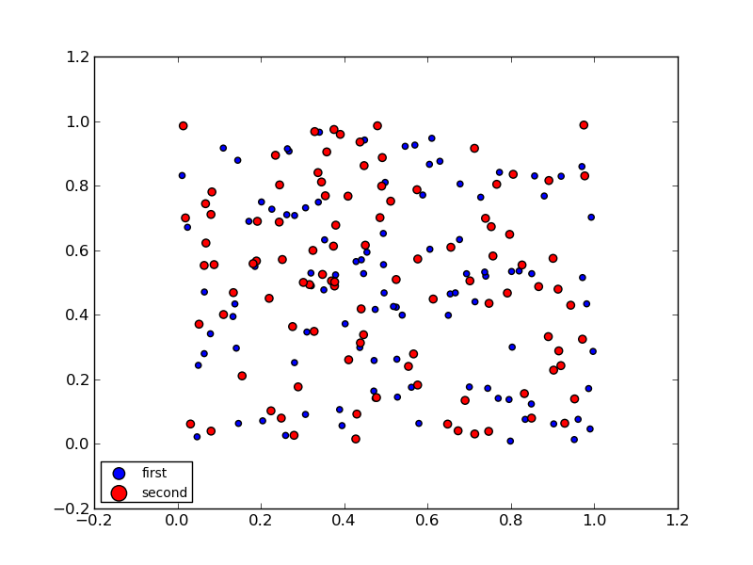

**NOTE:**

By default legend will be plotted in right top